**Single step enrolment flow:**

1. Packet creation which includes resident demographic and biometric details.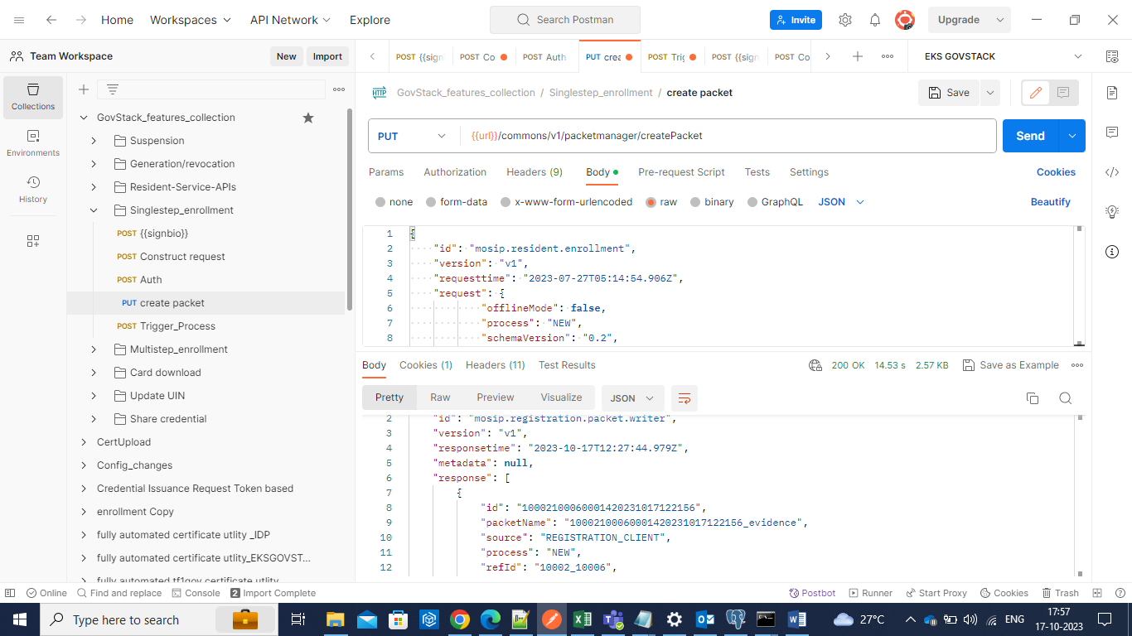

2)upload packet.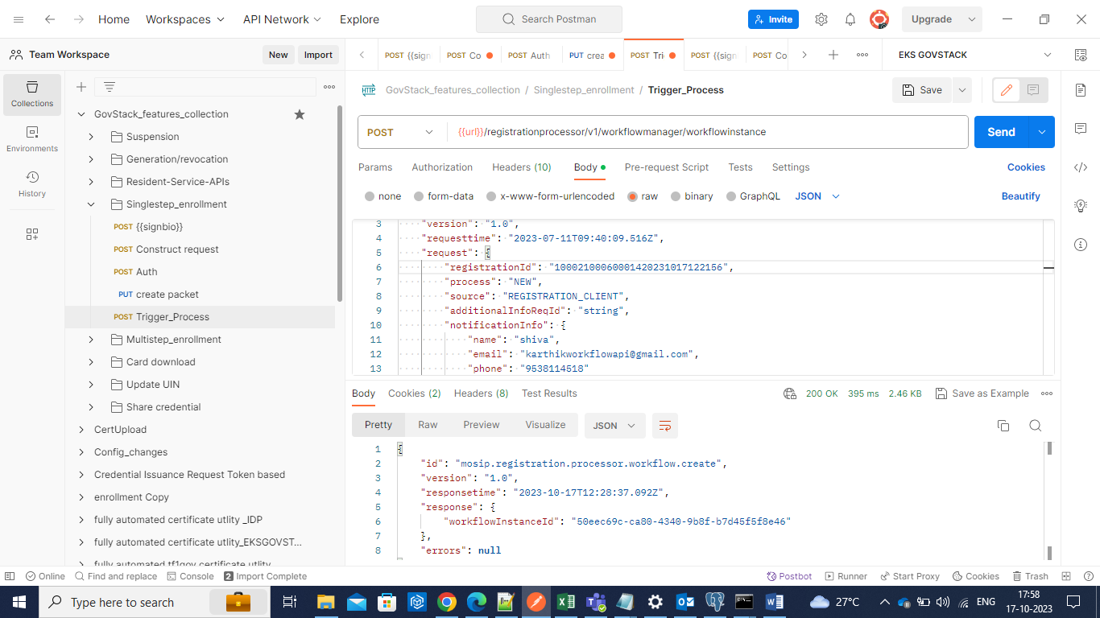

3)Notification for registration conformation and UIN generation.